Handout 1.10: Build a Plate
Lesson: 1.10 MyPlate Beyond the Food Groups Print: Pages 1 and 2, one per student. Page 3 (the plate check) is private; print it on its own sheet so it can be folded and handed in face down.

Page 1: MyPlate is about how much
Name: ______________________________ Date: ______________ Period: ______
Part A. Fix your do now circle. Divide the plate below the way MyPlate really does it. Label the four sections on the plate and the cup beside it. Write one food in each.
The four rules:
- Half the plate is fruits and vegetables. Vegetables get a little more room than fruit.
- The other half is grains and protein foods. Grains get a little more room than protein foods.
- Dairy is on the side in a cup (milk, yogurt, or a calcium-fortified soy drink).
- Make half your grains whole grains.
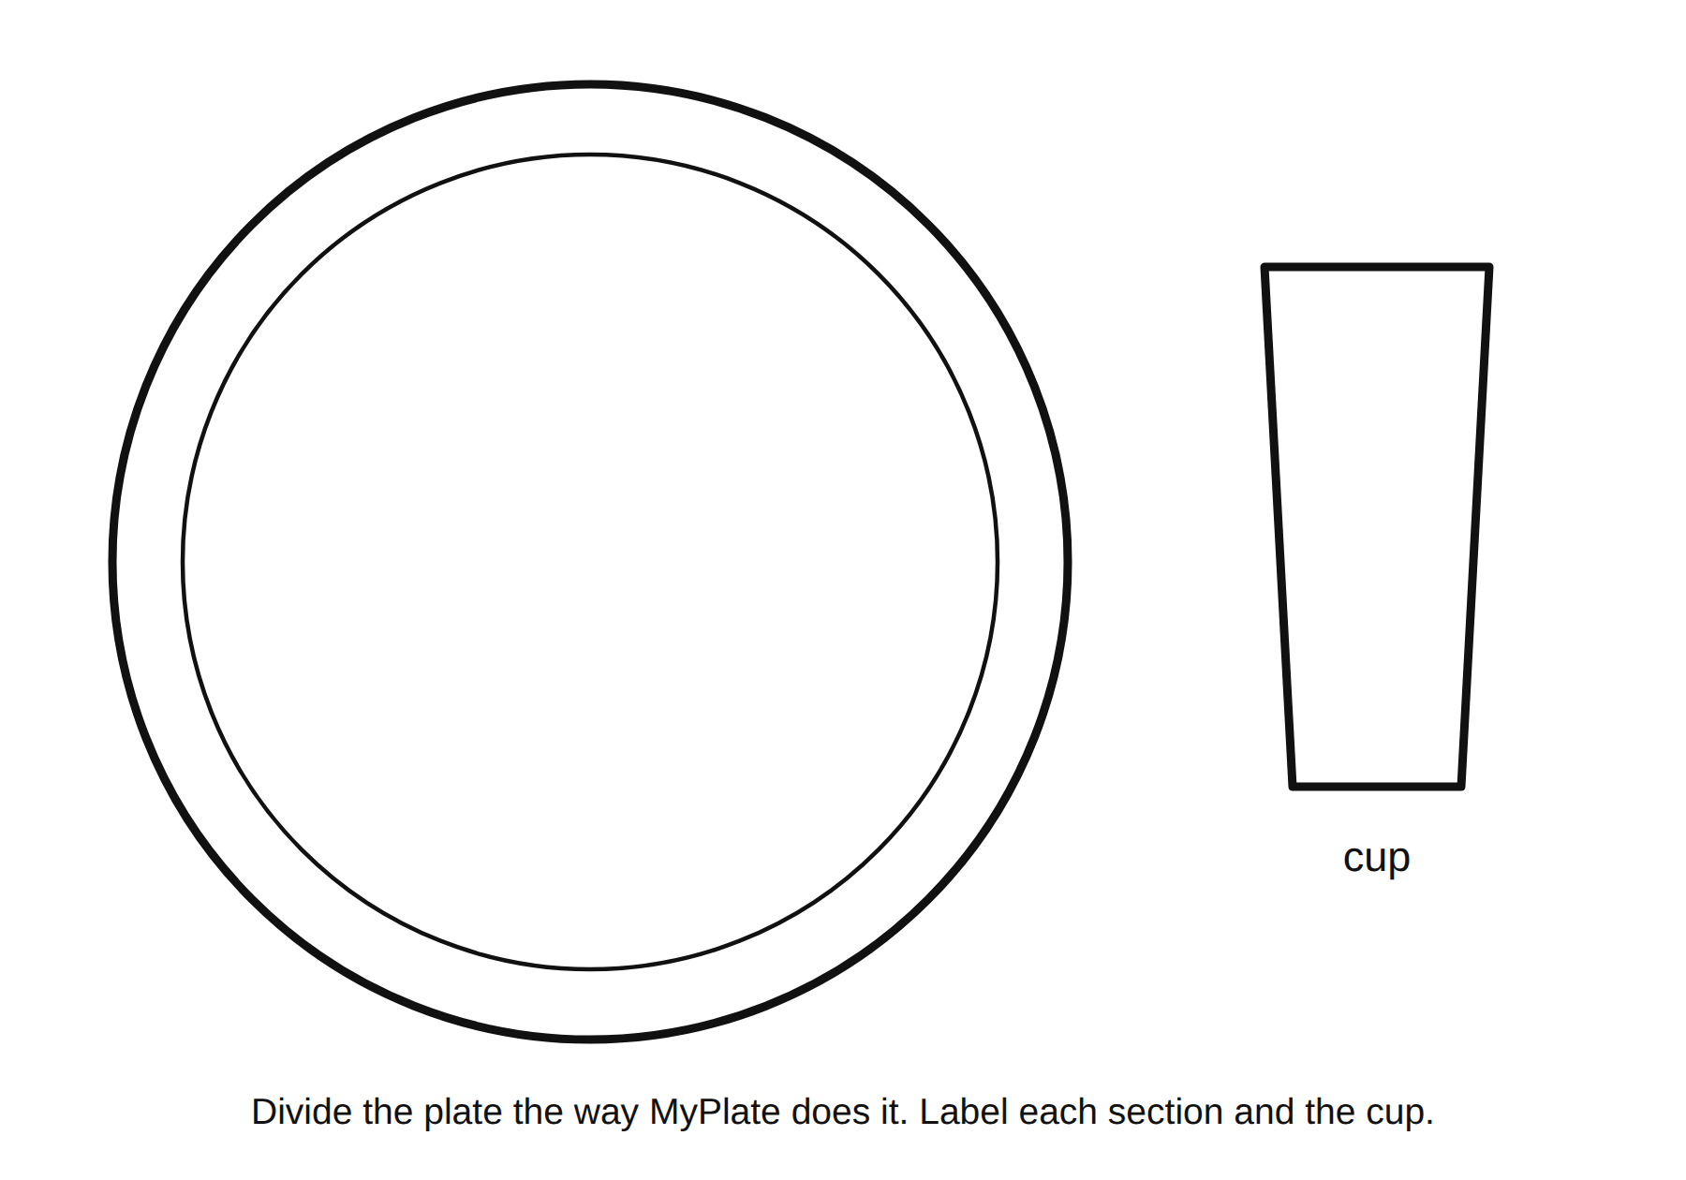
An empty plate and a cup, to divide and label the MyPlate way
Section 1 (top left): ______________________ Food: ______________________ Section 2 (top right): ______________________ Food: ______________________ Section 3 (bottom left): ______________________ Food: ______________________ Section 4 (bottom right): ______________________ Food: ______________________ Cup: ______________________ Food: ______________________
Part B. Serving or portion? Write each one in your own words.
A serving is _____________________________________________________________________
A portion is _____________________________________________________________________
The family size chip bag on the demo table: my guess for servings in the bag ______. The label says ______.

Page 2: Build your plate
Directions: Use the food cards and your paper plate. Build a dinner that follows the four rules. Every section filled. At least one whole grain. Protein foods from two different sources if you can (for example, beans and chicken). Then draw it here.
My plate (draw and label)
Whole grain on my plate: ______________________
Two protein foods: ______________________ and ______________________
Partner check. Trade handouts. Look at your partner’s plate. Name one section that looks too big or too small, or write “matches MyPlate.”
Partner’s comment: _______________________________________________________________
Partner’s signature: ______________________
Serving and portion on my plate. Pick one food from your plate.
Food: ______________________ One serving of it is about ______________________ (use the slide). The portion I would actually eat is about ______________________.
Grade 8 stretch: build the plate for the teen athlete OR the grandparent from Lesson 1.9. Which section changed and why? _______________________________________________

Page 3: My plate check (private)
This page is yours. Nobody reads what you ate. I check that it is filled in, not what is on it. Fold it in half and hand it in face down.
Yesterday, I ate: (list foods, or just circle the groups you ate from if you would rather)
Morning: ___________________________________________________________________
Midday: ____________________________________________________________________
Evening: ___________________________________________________________________
Snacks: ____________________________________________________________________
Groups I ate from yesterday (circle): Fruits / Vegetables / Grains / Protein foods / Dairy
Movement yesterday. Minutes I moved (walking to school, gym, sports, dancing, chores, anything that got you breathing harder): about ______ minutes.
The guideline for ages 6 to 17 is 60 minutes or more a day.
What came up short? Circle ONE MyPlate group that was missing or small: Fruits / Vegetables / Grains / Protein foods / Dairy
Movement was: under 60 minutes / about 60 / more than 60
One change I could actually make this week (small enough to really happen):
_____________________________________________________________________________

